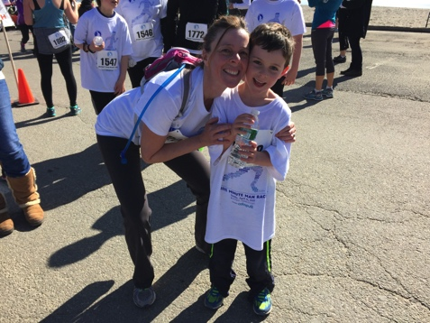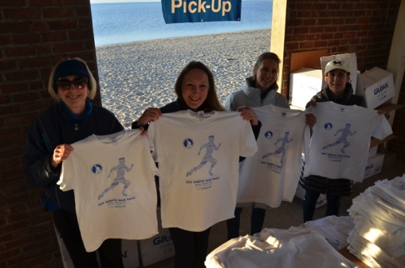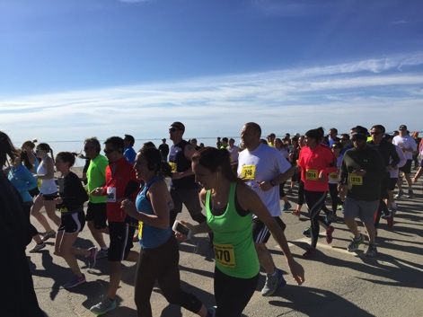

38th Annual
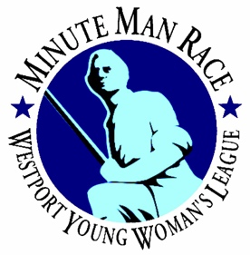
MINUTE MAN RACE
Sunday, May 1, 2016

Do something good for your heart – sponsor us!

2016 marks the 38th anniversary of the Minute Man Race! This fundraiser, organized by the Westport Young Woman’s League, is a family-friendly, community-wide event — and it truly couldn’t be what it is today without the generosity of our local businesses.

This year, the race will be held on Sunday, May 1st at Westport's scenic Compo Beach. It includes a 5K Run/Walk, a 10K Run, and Kids' Races. Runners will even get to cruise by the very Minute Man statue himself. Over 1,300 people participated last year, allowing us to raise more than $34,000 for local charities. In fact, since our inception in 1956, the Westport Young Woman’s League has given over $4.3 million to a broad range of organizations in Fairfield County. With the help of businesses such as yours, we support cultural mainstays like the Summer Reading Program at Westport Library and the Summer Concert Series at the Levitt Pavilion as well as dozens of programs for at-risk youth, seniors and families in need, among others.

Do something good for your heart; sponsor the Minute Man Race! Thank you for helping us to make a difference right here in Fairfield County.

Deb Bayazit Dayna Sproule
Minute Man Race Chair Sponsor Chair
MinuteMan@wywl.com Sponsors@wywl.com
917-545-1347

Our Mission Statement: Westport Young Woman’s League is a grassroots non-profit philanthropic organization of women committed to promoting a sense of community through volunteerism, social activities, and fundraising for local charities.
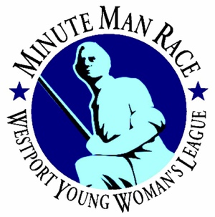
Sponsorship Levels
Sponsors will receive the following in addition to the special benefits at their level:
- Logo on promotional materials & social media*
- Acknowledgement on the race poster*
- Booth space at event for marketing materials & your representative*
- Logo/Acknowledgement on our website wywl.com & Facebook page
- Full rights to Minute Man marks and logos
- Logo on event t-shirt
- Signage at event
- Race entry forms
*Includes all sponsor levels except $500 Event Sponsor

$5,000 Platinum Sponsor
- Exclusive branding on race results page
- Exclusive branding on results text message sent to all runners
- 18 race entries ($540 value)

$5,000 Pace Car Sponsor
- Exclusive dealership opportunity to market & pace our race!
- 18 race entries ($540 value)

$3,000 Registration Sponsor TAKEN
So happy to have Performance Physical Therapy join us again!
- Exclusive pre-registration location on Saturday, April 30th.
- Approximately 700 people will register/pick up race materials!
- 14 race entries ($420 value)

$1,000 Gold Sponsor
- 5 race entries ($150 value)

$500 Event Sponsor
- 5 race entries ($150 value)

Kid’s Race Sponsor TAKEN
We are so lucky to have Mark Carmody of Peak Performance Sports organize our kids’ races. We are ecstatic to have them as part of our event again!

Food Sponsor TAKEN
We are thrilled to have Whole Foods come back for a second year!

Water Sponsor TAKEN
Thank you to Poland Springs for being our water sponsors for many, many years – including this one!
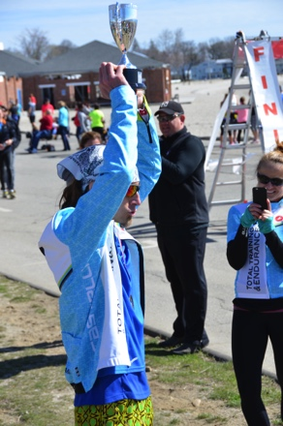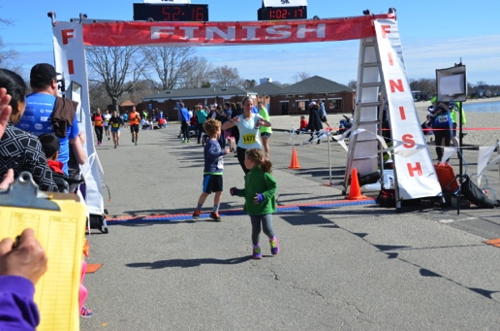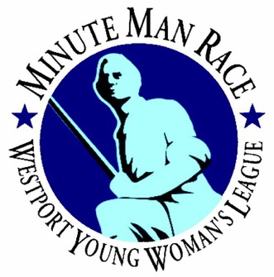
Sponsorship Contract

Sponsor Level _____________________________________________________

Contact Name: _____________________________________________________

Company: _____________________________________________________

Address: _____________________________________________________
_____________________________________________________

Phone: _____________________________________________________

Email: _____________________________________________________

URL: _____________________________________________________

Signature: ___________________________________________________ Date______________________

Important Dates: To guarantee your company name is on our marketing materials and the t-shirt, we must receive your payment by no later than March 7, 2016. The sooner we receive your logo, the sooner we can put it on our website and social media.
Payment, logo & links due: March 7, 2016

Artwork: Logos should be in .EPS or .TIFF format and emailed to sponsors@wywl.com
Payment & Contract: Please make checks payable to the Westport Young Woman’s League (WYWL). Mail this contract (make a copy for yourself) and payment to our new address.
Westport Young Woman’s League
Dayna Sproule
Sponsor Chair
P.O. Box 333
Westport, CT 06881

As a condition to participating in the race, the sponsor expressly releases the WYWL from all claims for damages resulting from the cancellation of the race for any reason whatsoever. As a further condition of participation, the sponsor expressly releases the WYWL from all liabilities for any injury or loss resulting from any cause incurred during the race, including set-up and take down periods. The sponsor agrees to provide all necessary material as agreed upon by sponsor and the WYWL.
Any questions? Call Dayna Sproule, Sponsor Chair, at 917-545-1347

